771762-Big Data and Data Mining – Project Report

Analysis of UK Road Traffic Accident Data (2018)
Word Count: 3806

- Introduction
This report analyses the accident_data_v1.0.0_2023 database, encoded under the STATS19/STATS20 (2011) standard (Department for Transport, 2011), to advise the Department for Transport (DfT) on evidence-based road safety interventions. The database covers injury accidents in Great Britain between 2017 and 2020 across three interlinked tables (accident, vehicle, casualty); analysis focuses on the 122,580 records of 2018. Seven tasks are addressed: temporal patterns of all road users, motorcyclists and pedestrians; association rule mining of severity conditions; spatial clustering in West Yorkshire; time series forecasting of weekly accident counts across three police areas and daily counts of West Yorkshire’s highest-incident LSOAs.
- Analysis and Results
2.1 Data Cleaning and Pre-processing
The raw database was loaded via a read-only SQLite connection. Dates were parsed with dayfirst=True; time strings were converted to integer hours (0-23). Day-of-week was decoded using DfT, 2024 encoding (1=Sunday…7=Saturday). Before any analysis, all categorical codes were coded into human-readable labels using verified STATS20 (2011) dictionaries. Records that lacked date, hour, latitude, or longitude were eliminated (126 records; 0.03%). The 2018 subset comprised 97,953 slight, 22,957 serious, and 1,678 fatal accidents (STATS20 §3.9). For SARIMA forecasts, the resampled series had missing periods zero-filled to produce the contiguous sequences required.
2.2 Temporal Patterns
All Accidents
Accident frequency peaked at 17:00 and was highest on Fridays. Figure 3 (heatmap) shows two concentration bands, a morning peak (07:0019:00), and a stronger PM peak (15:0018:00) on Monday-Friday. Chi-square testing confirmed highly significant associations between time period and both severity (p<0.001) and light conditions (p<0.001). The PM Rush (13:0016:00) had the largest absolute counts of all severities (6,316 serious; 398 fatal), which was motivated by traffic volumes. Evening hours (17:00–19:00) showed a disproportionate shift toward lit-darkness accidents (8,265 under street-lit conditions), indicating that reduced contrast compound risk beyond what volume predicts. Across all periods, single carriageways accounted for >65% of accidents; urban areas for 66-72%, with urban share rising after dark.
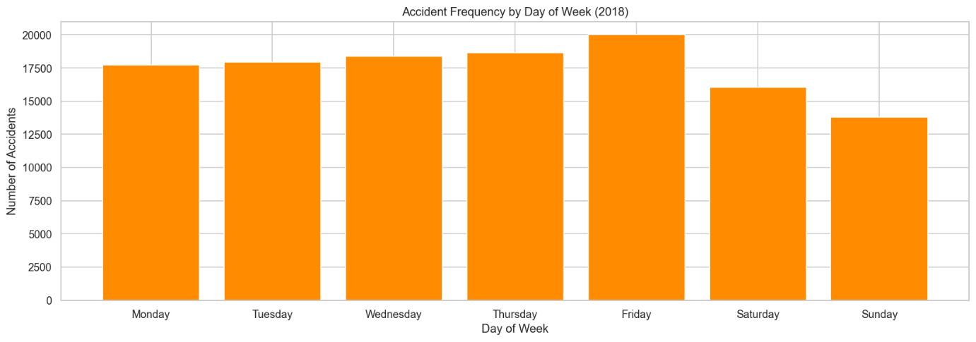
Figure 1. Accident frequency by day

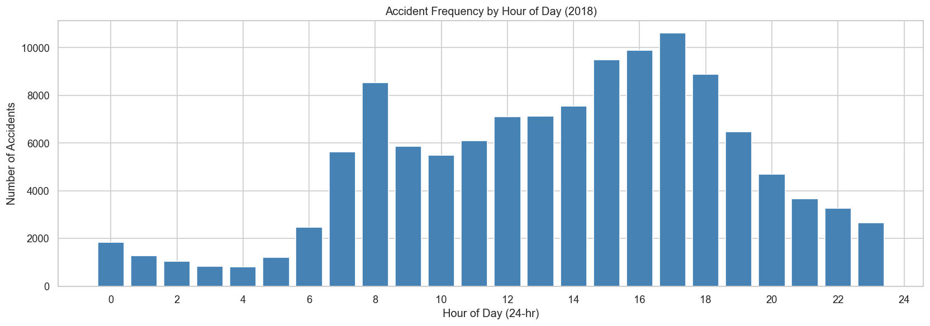
Figure 2: Accident frequency by hour

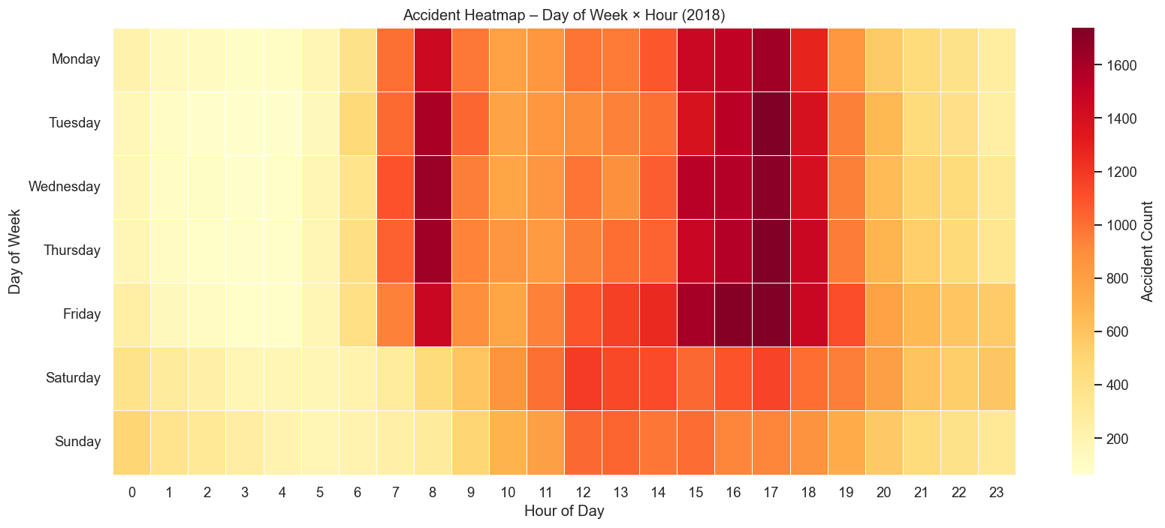
Figure 3: Day × hour heatmap with accident count colour scale. Peak is at 17:00 on Fridays.

Motorcycle Accidents by Engine Category
Motorcycles ≤125cc peaked on weekday commuting hours (08:00–09:00; 17:00–18:00) and concentrated on unclassified urban roads (31.7%). The 126-500cc category bikes showed a more balanced pattern with a peak on Friday (17:00–18:00). Bikes with larger engines (>500cc) showed peaks on weekend-afternoons (Saturday-Sunday, 11: 00-15: 00), indicating recreational usage, and higher A-road and dual-carriageway exposure (>500cc: 17.4% dual carriageway vs. ≤125cc: 12.2%). The >500cc category was disproportionately represented in 51-70mph zones, and had a fatal proportion almost three times that of the ≤125cc category. This shows the compound effect of high speeds and open-road environments on crash survivability.
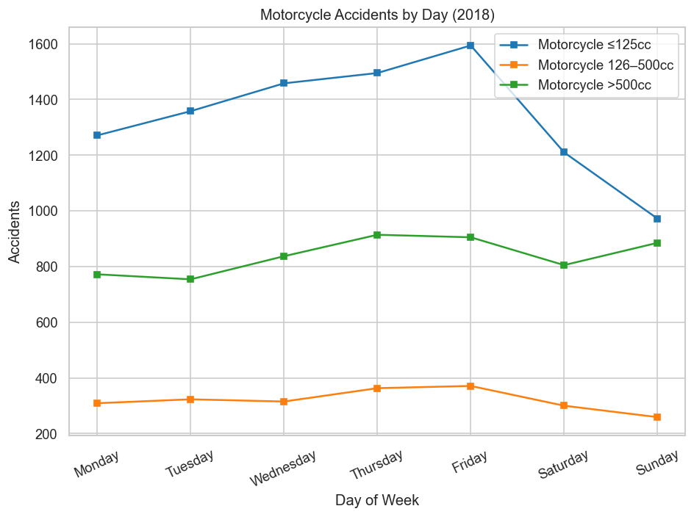
Figure 4. Motorcycle Accident frequency by day
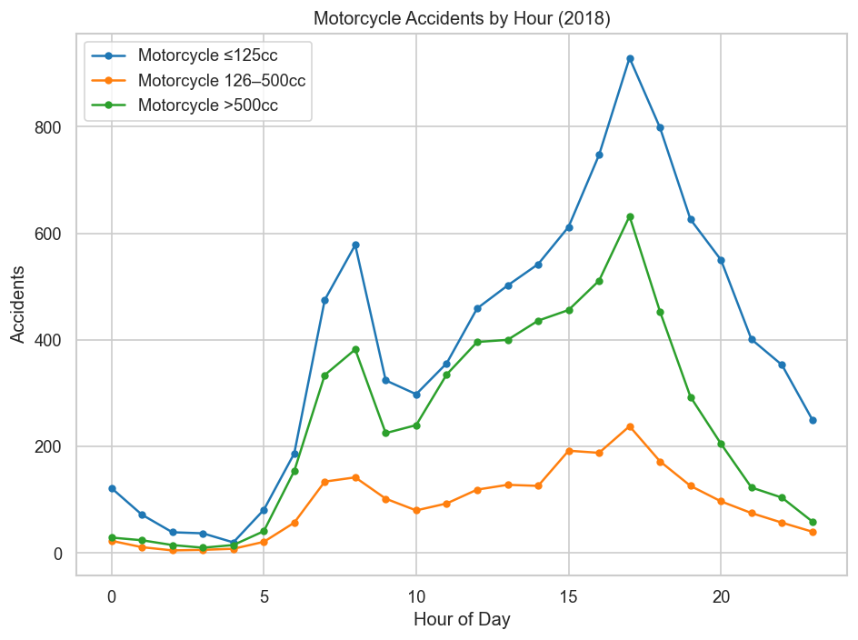
Figure 5. Motorcycle accident frequency by hour
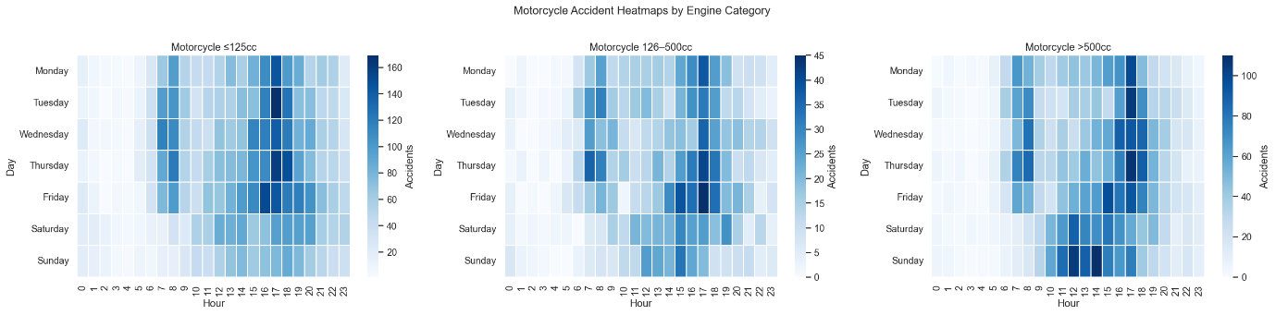
Figure 6. Day × hour heatmaps per group. The weekday commuter pattern (≤125cc) and weekend recreational pattern (>500cc) are clearly distinguished.
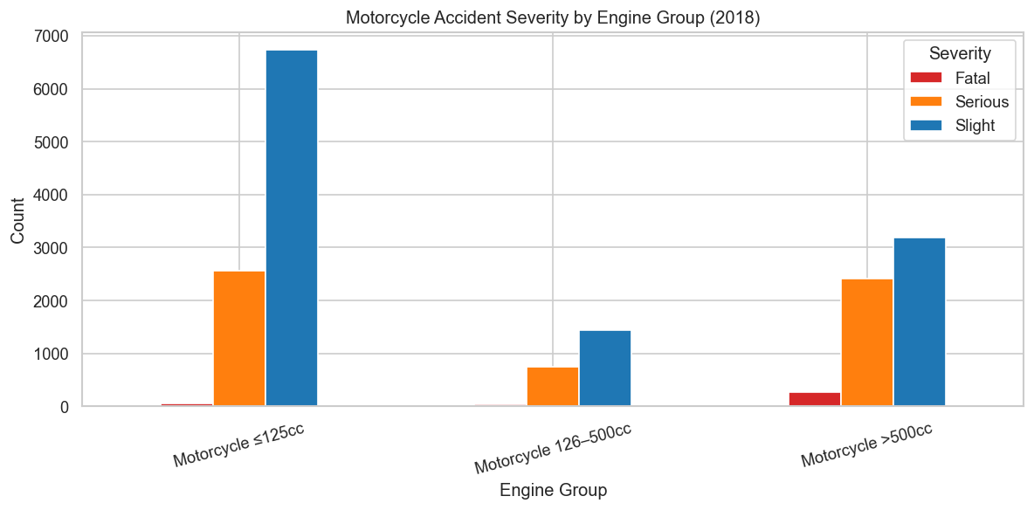
Figure 7. Motorcycle accident Severity by engine group

Pedestrian Accidents
There were 22,975 pedestrian casualties in 2018. Chi-square analysis confirmed significant associations (all p<0.001) between time period and pedestrian movement type, location type, and light conditions. Two separate temporal regimes emerged. During AM and PM rush hours, crossing-from-nearside was predominant (31-34% of movements), representing pedestrian conflict with turning vehicles at crossings and informal crossings; AM Rush also had the highest proportion at formal crossing facilities (17.8%). Evening hours (17:00 -19:00) showed a strong peak caused by post-work foot traffic and worsening light conditions, whereas late-night accidents (20:00 -23:00) shifted toward in-carriageway non-crossing incidents (12.8%) and unlit conditions (2,129 accidents), which could be associated with impaired pedestrian behaviour after dark. The most common type of location across all periods was crossing elsewhere (figure 10) without a designated facility (30-43%), which exposes a structural deficit that needs to be met by exposure and better facilities.
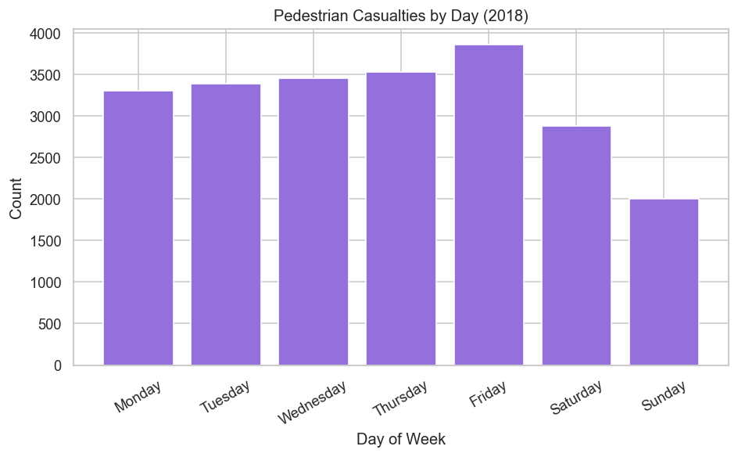
Figure 8. Pedestrian casualties by day

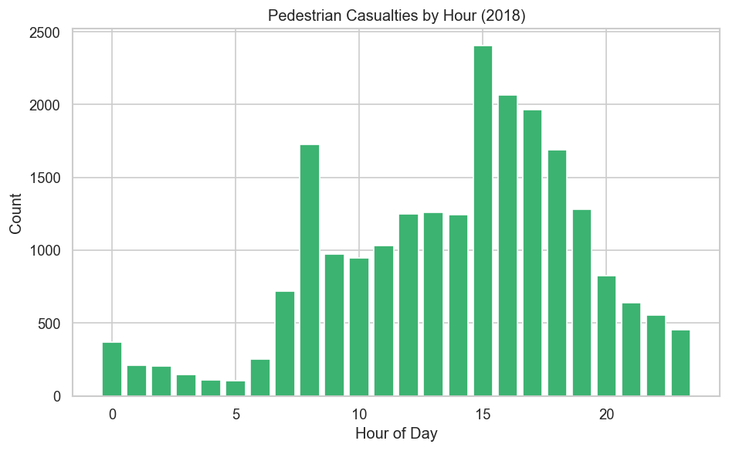
Figure 9. Pedestrian casualties by hour

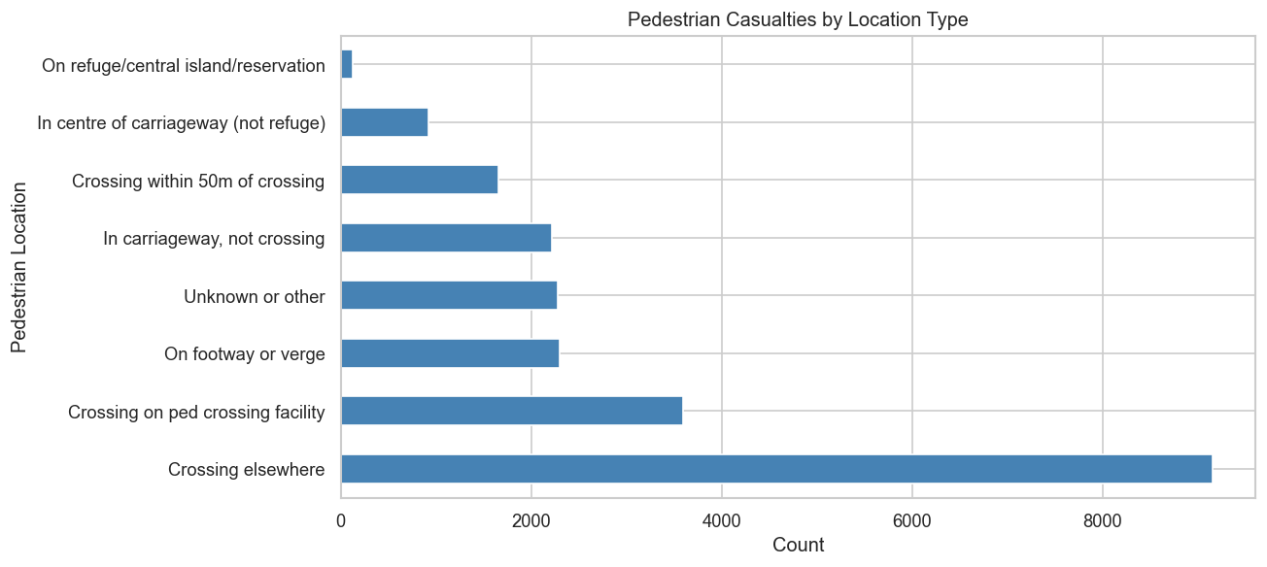
Figure 10. Pedestrian casualties by location type

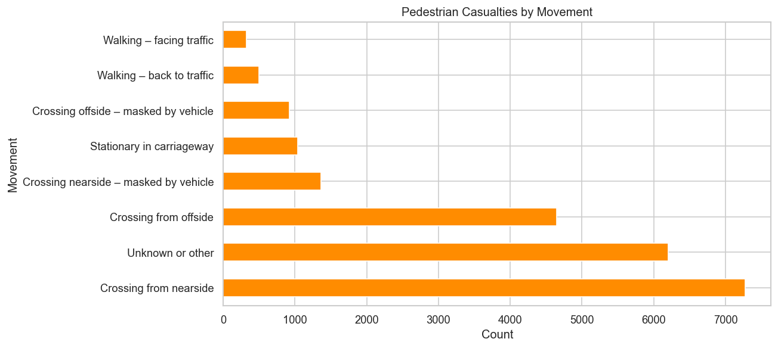
Figure 11. Pedestrian casualties by movement

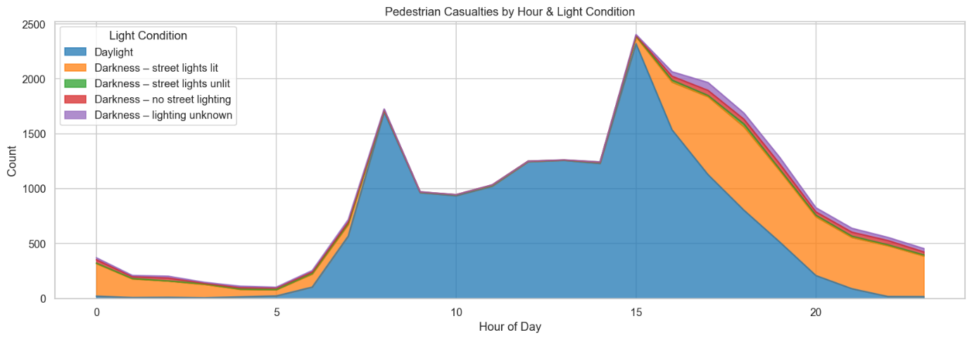
Figure 12. Pedestrian casualties by hour and light condition

2.3 Association Rule Mining
Apriori algorithm (Agrawal and Srikant, 1994) was used on the 2018 data of accidents with a minimum support of 0.05 and a confidence threshold of 0.50, encoding nine STATS20-labelled features (weather, road surface, light conditions, speed limit band, road type, urban/rural, junction type, and time period) across 122,580 transactions × 52 items. This produced 1,615 frequent itemsets and 3,666 severity-related rules. Table 1 presents the top rules by lift.

Rule | Antecedents (conditions) | Consequents (outcome) | Supp. | Conf. | Lift
R1 | Raining, no high winds | Slight + Urban + Wet/Damp | 0.055 | 0.524 | 4.52
R2 | Raining, no high winds | Slight + Speed ≤30mph + Wet/Damp | 0.055 | 0.524 | 4.48
R3 | Urban + Raining, no high winds | Slight + Wet/Damp | 0.055 | 0.801 | 4.40
R4 | Speed ≤30mph + Raining, no high winds | Slight + Wet/Damp | 0.055 | 0.798 | 4.38
R5 | Raining, no high winds | Slight + Wet/Damp | 0.082 | 0.783 | 4.30
R6 | Single carriageway + Raining, no high winds | Slight + Wet/Damp | 0.056 | 0.772 | 4.23
R7 | Raining, no high winds | Slight + Wet/Damp + Single carriageway | 0.056 | 0.535 | 4.16
R8 | Urban + Late Night | Slight + Dark – street lights lit | 0.051 | 0.606 | 3.80
R9 | Daylight + Fine, no high winds + Speed 51–70mph | Dry + Rural + Slight | 0.065 | 0.573 | 3.40
R10 | Dry surface + Speed 51–70mph | Slight + Daylight + Fine, no high winds + Rural | 0.065 | 0.518 | 3.38
Table 1. Top association rules by lift.

Rules R1-R7 describe the same fundamental pattern: rain, wet surfaces, and slight severity are strongly co-associated (lift: 4.16-4.52). The rules vary only in additional contextual conditions. This is a counterintuitive but important finding: wet weather in low-speed urban environments generates many minor collisions, but those same conditions cap crash energy. R3 and R4 achieve the highest confidence (0.80) because restricting to urban or ≤30mph environments produces a near-homogeneous, slight-outcome subset. Rules R9-R10 are the key policy contrast: dry, fine weather at 51-70mph roads associated with slight severity but notably lower lift (lift 3.38-3.40). While slight outcomes dominate numerically, this environment generates the most serious and fatal cases. This is highlighted in the cluster analysis in Section 2.4. The scatter plot (Figure 13) proves that the high-lift cluster in the moderate-support, high-confidence region, which implies that they are reliable and applicable to a significant proportion of accidents.
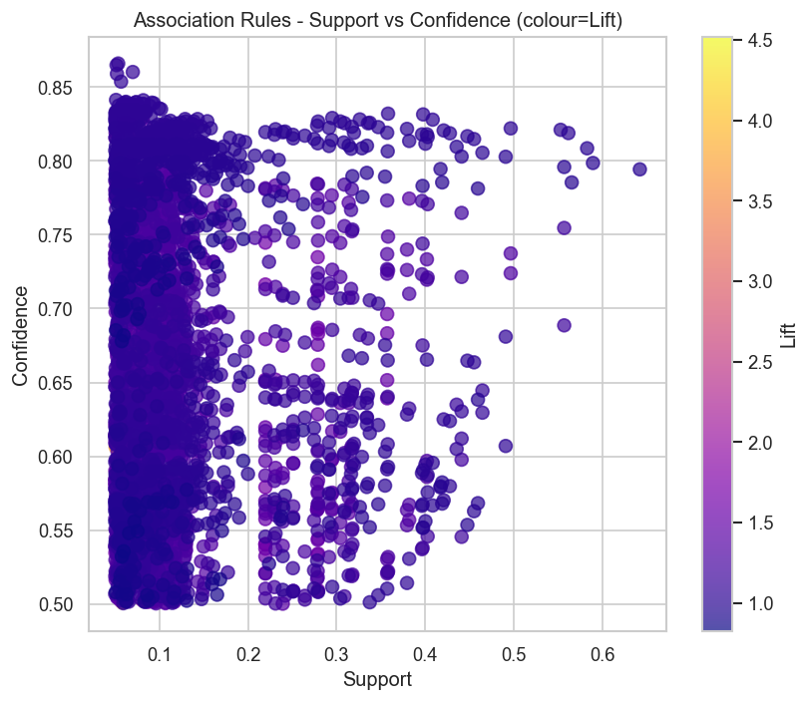
Figure 13. scatter of all 3,666 severity-related rules coloured by lift
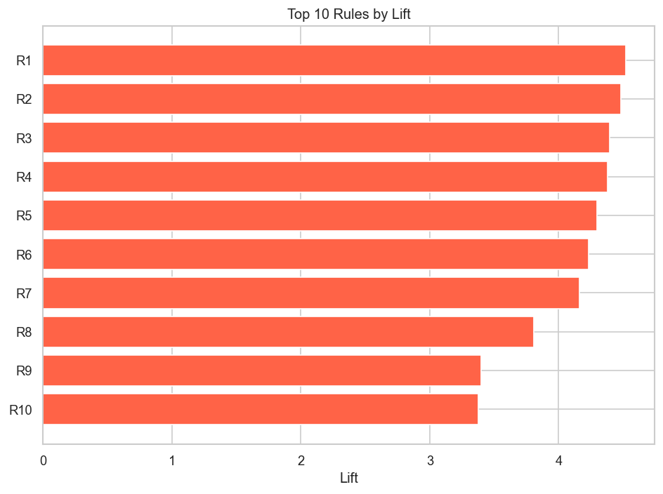
Figure 14. Top 10 rules by lift (Rules in table 1)
2.4 Spatial Clustering in West Yorkshire
In 2018, West Yorkshire (police force 13, STATS20 Annex 6) recorded 4,132 accidents. The feature matrix combined spatial coordinates with STATS20-coded attributes (severity, hour, speed limit, light conditions, road type, urban/rural), standardised by z-score. Silhouette analysis selected k=2 for KMeans. Cluster 0 (n=3,314; avg speed limit 30.7 mph; 1.1% fatal) was centred on the Leeds-Bradford conurbation. Cluster 1 (n=818; avg speed limit 51.7 mph; 3.2% fatal) followed the M62/A1M corridor and Pennine arterial routes, a fatal rate almost three times that of Cluster 0. This confirms that speed limit is a better predictor of fatal risk than accident volume. DBSCAN (Figure 16) (eps=0.03, min samples=15) complemented this by identifying dense spatial hotspots within the region, separating core clusters from isolated incidents. Both algorithms provide complementary insights: KMeans reveals contextual regime differences; DBSCAN maps physical hotspot geography (Figure 15).
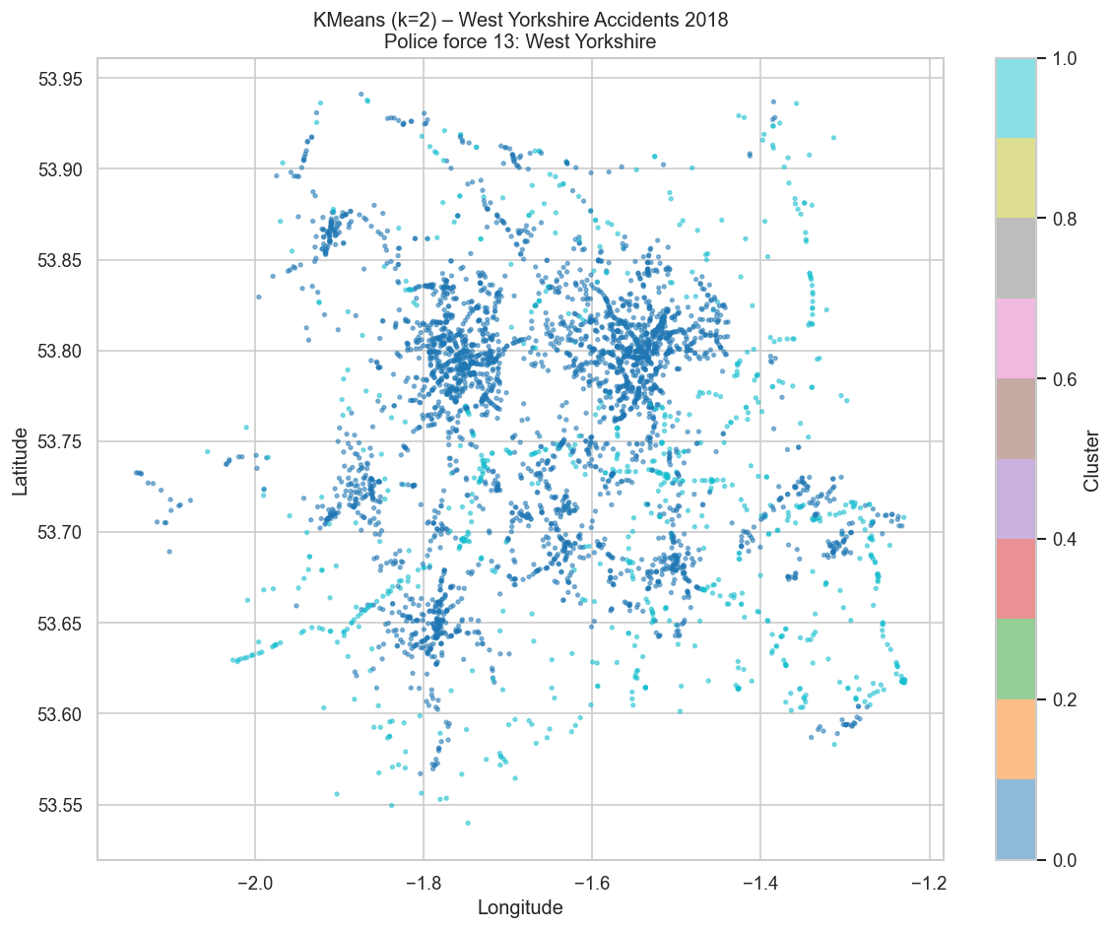
Figure 15. KMeans (k=2) cluster map (West Yorkshire)
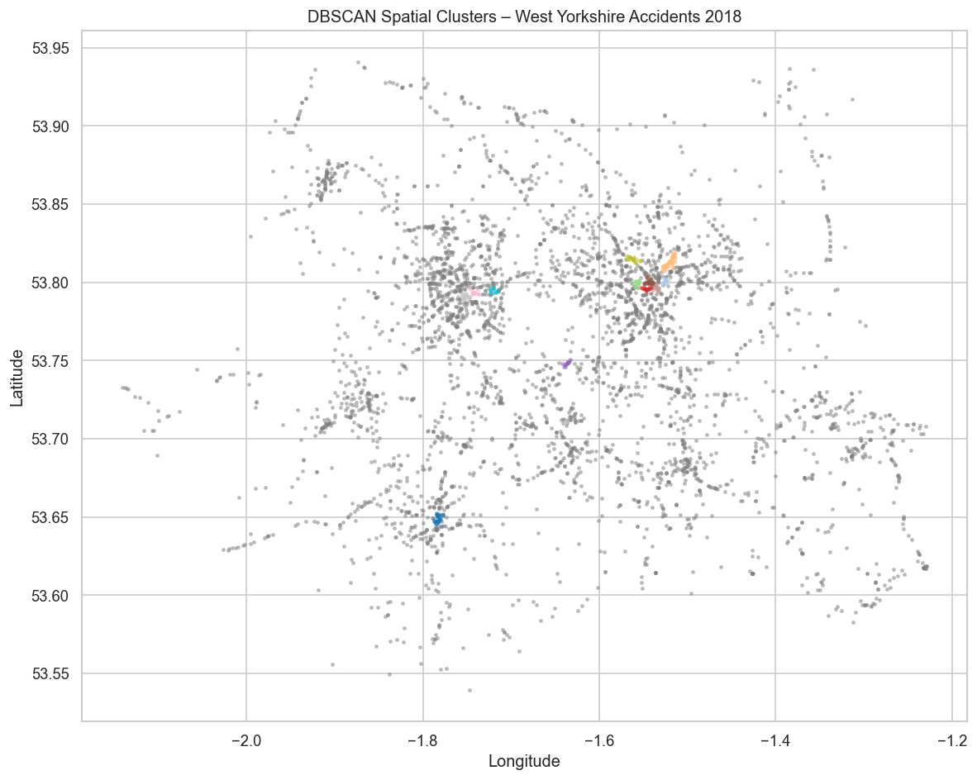
Figure 16. DBSCAN density-based hotspot map highlighting core accident concentrations.
2.5 Time Series Forecasting (Weekly Forecasts Across Three Police Areas)
Three policing areas were selected using STATS20 Annex 6 codes: Metropolitan Police (01), West Yorkshire (13), and Thames Valley (43), representing a high-volume urban force, a medium regional force, and a semi-rural force, respectively. ADF tests confirmed stationarity in all three weekly accident series (all p<0.0001). SARIMA models were fitted via grid search of p,q∈{0,1,2} with d=1 and seasonal order (1,1,1,52) to capture annual weekly seasonality. Grid search selected order (0,1,0) as optimal for all three areas, which is consistent with near-random-walk behaviour in weekly counts after differencing. Ljung-Box tests on all residual series confirmed no significant autocorrelation at any lag (all p>0.05), validating model adequacy.

Police Area (STATS20 Annex 6) | RMSE (weekly accidents) | MAPE (%)
Metropolitan Police (Force 01) | 47.10 | 6.98
West Yorkshire (Force 13) | 16.60 | 18.97
Thames Valley (Force 43) | 15.36 | 19.16
Table 2. SARIMA model performance for the 2019 test year (Task 6).

The Metropolitan Police had the lowest MAPE (6.98%) despite the highest absolute RMSE, because its large baseline volume (25,384 records in 2018) provides a stable seasonal signal against which the forecast can anchor. West Yorkshire and Thames Valley had higher MAPE values (≈19), partly because smaller weekly counts mean minor absolute deviations produce larger percentage errors. All three models captured the broad seasonal structure, showing higher accident count in summer, and lower in winter, but underestimated the intermittent peaks of bank holidays (Figures 17, 18, 19).
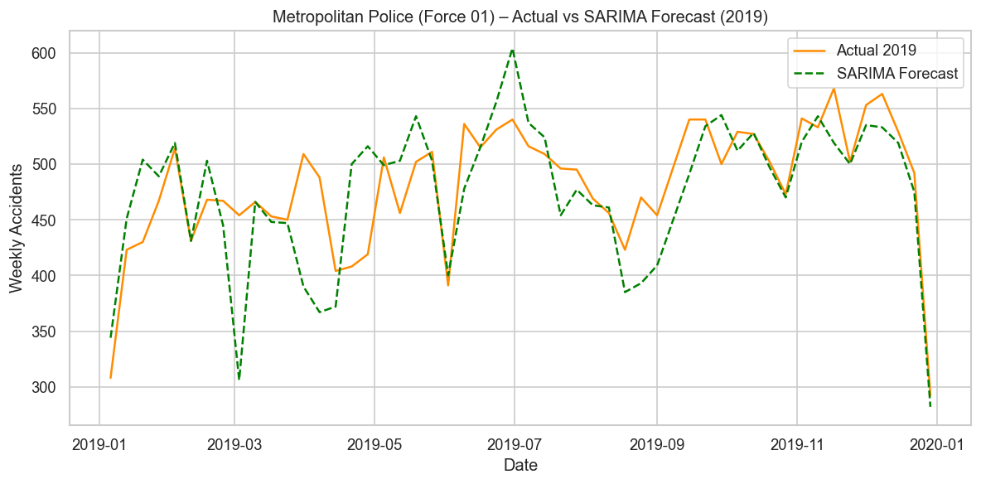
Figure 17. SARIMA weekly accident count forecasts (green dashed) against actual 2019 counts (orange) for Metropolitan Police

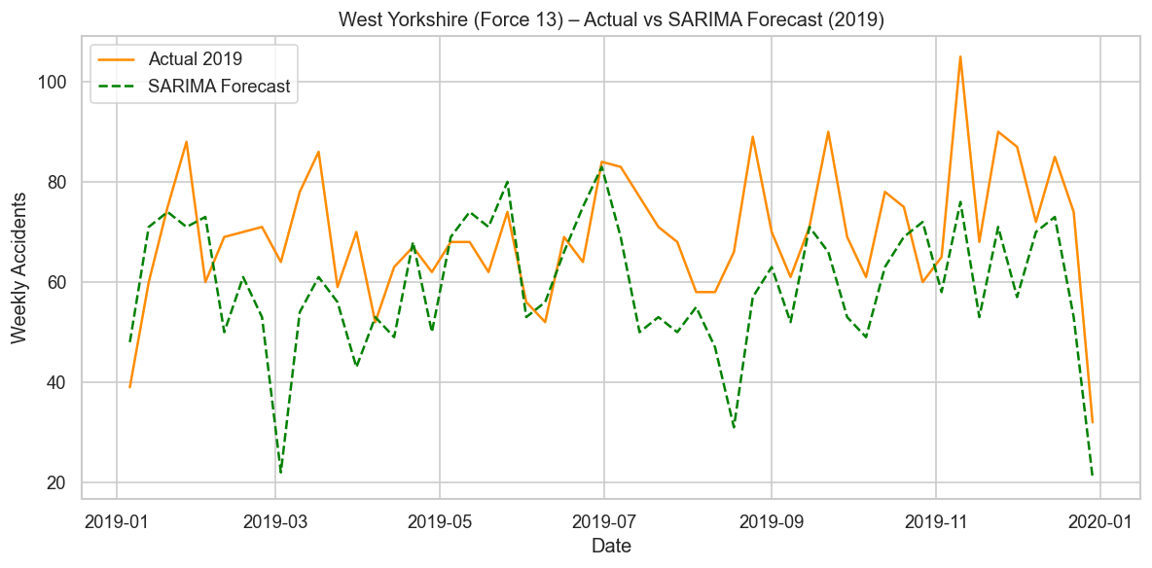
Figure 18. SARIMA weekly accident count forecasts (green dashed) against actual 2019 counts (orange) for West Yorkshire

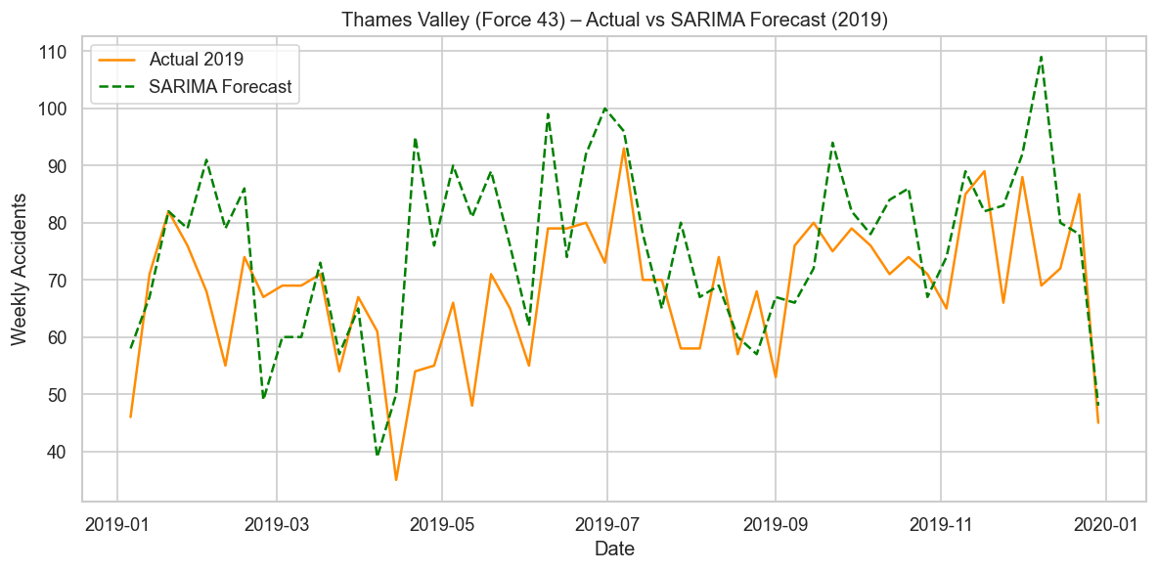
Figure 19. SARIMA weekly accident count forecasts (green dashed) against actual 2019 counts (orange) for Thames Valley.
Daily Forecasts for Top-30 West Yorkshire LSOAs
The top 30 high-incident 2018 LSOAs in West Yorkshire averaged 1.48 accidents daily from January-June 2018 (max 6; SD 1.25). The series showed a clear weekly rhythm confirmed by a significant lag-7 spike in ACF/PACF analysis, motivating SARIMA with a seasonal period m=7. The model forecasted 1.06 accidents/day for July 2018. Ljung-Box residuals showed no autocorrelation of any lag (all p>0.71). Forecast of RMSE=1.06 against a mean of 1.48 is a good performance given the inherent stochasticity of daily LSOA-level accident counts. Most of the real observations fell within the 95% confidence interval (Figure 7).
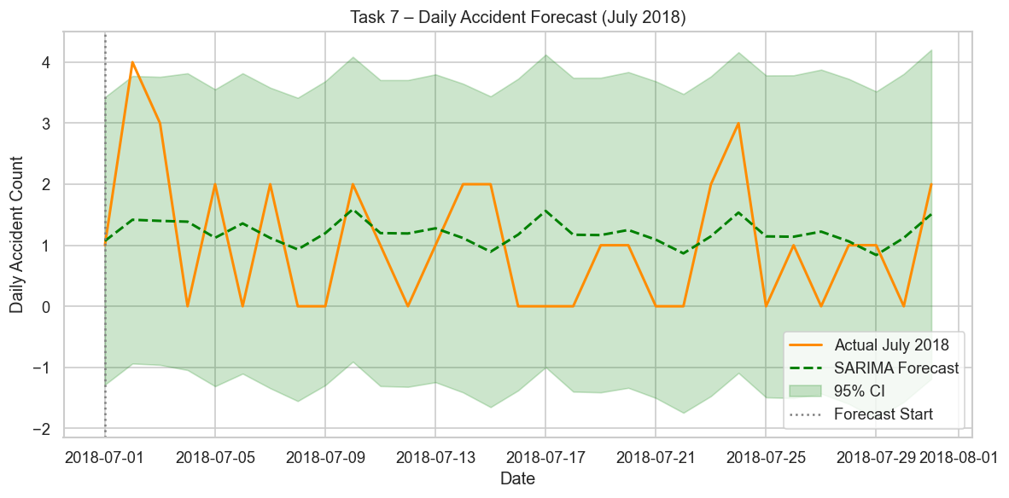
Figure 20. Daily accident forecast (green dashed) against actual July 2018 counts (orange). 95% confidence interval shaded.
- Discussion
Three common themes are revealed in the analysis. First, the AM/PM rush hours and Friday drive the highest absolute accident volumes, but severity analysis reveals that rural high-speed environments are disproportionately fatal. The rural cluster of West Yorkshire (Cluster 1) had a 3.2% fatal rate compared to 1.1% in the urban cluster, a trend that is also broadly representative of the national finding that rural roads account for approximately 60% fatalities despite lower traffic volumes (DfT, 2019).
Second, the Apriori results dispute a common assumption that poor weather correlates with severe outcomes. Rules R1-R7 prove that rain and wet surfaces strongly predict slight, not serious, accidents, since the crash energy is limited by low-speed urban environments, where most wet-weather incidents occur. R9-R10 captures the truly threatening conditions: 51-70mph dry rural roads correlated with serious and fatal outcomes.
Third, the time series results show moderate predictability at weekly resolution (MAPE 7-19%) and meaningful rhythmic structure at daily LSOA resolution, with SARIMA effectively capturing the weekly accident cycle. The advantage of high-volume data in stabilising seasonal estimates is reflected by the superior MAPE of the Metropolitan Police (6.98%). A key limitation is that the contributory factor field, which records the attending officer's assessment of why an accident occurred, was largely unpopulated in the 2018 data; Apriori rules represent co-occurrence, not causation. KMeans clustering is also sensitive to k selection, and the silhouette optimal k=2 may not capture the full complexity of accident regimes across a geographically varied region.
- Recommendations
Rural speed management on high-risk routes. Apriori rules R6-R7 and West Yorkshire Cluster 1 co-identify 51-70mph rural roads as the highest-severity environment. The combination of average speed cameras on the M62/A1M corridor and Pennine arterial routes, along with mandatory Intelligent Speed Assistance (ISA) on newly registered vehicles, may reduce fatal accidents.
Pedestrian crossing infrastructure at hotspots. The most frequent site of pedestrian accidents in every time period (30-43%) was crossing elsewhere (no designated facility). The DfT should prioritise crossing provision at DBSSCAN-identified spatial hotspots in West Yorkshire’s urban core and fund 20mph zone expansion in the top-30 LSOA areas to address the AM rush pedestrian spike.
Dark-hours street lighting and visibility campaigns. Chi-square analysis confirmed darkness as a significant modifier of accident distribution. Street lighting adequacy reviews in the top-30 LSOA hotspots should accompany national campaigns to promote reflective clothing and phone-free walking at night.
Differentiated motorcycle policy by engine category. ≤125cc commuter bikes concentrate on urban unclassified roads during rush hours, where junction incidents dominate. Interventions include improving urban junction layouts with better traffic calming devices, e.g., speed bumps, supported by 20mph zone extensions in the affected residential streets. In contrast, >500cc recreational bikes peak on rural A roads on weekends, requiring targeted enforcement during those periods, financial incentives for advanced rider training through insurance discounts, and tighter graduated licensing for high-powered machines.
Predictive resource allocation. SARIMA models (MAPE 6.98–19.16%) provide a deployable weekly forecasting capability. All forces should integrate models into operational planning, and should focus road traffic resources on forecast high-count weeks (typically May–August) and on Friday AM/PM rush periods, to enable proactive rather than reactive road safety management.

References
Agrawal, R. and Srikant, R. (1994) ‘Fast algorithms for mining association rules’, Proceedings of the 20th VLDB Conference, pp. 487–499.
Department for Transport (2011) STATS20: Instructions for the Completion of Road Accident Reports from non-CRASH Sources. London: DfT.
Department for Transport (2019) Reported Road Casualties Great Britain: 2018 Annual Report. London: DfT.
Department for Transport (2024) Road Safety Open Dataset Data Guide. London: Department for Transport. Available at: https://www.gov.uk/government/statistical-data-sets/road-safety-open-data (Accessed: 2 May 2026).

Social Network Analysis - Facebook EGO-Network (SNAP)
- Introduction
This exercise examines the SNAP facebook_combined.txt dataset: an undirected edge list of anonymised friendship connections pooled across 10 ego-networks on Facebook (Leskovec and Mcauley, 2012). The network was constructed using NetworkX’s read_edgelist() with self-loops removed (Hagberg et al., 2008). Three objectives are addressed: characterising the network’s structural properties and visualising the graph; computing and interpreting edge betweenness centrality; and detecting communities using two algorithms and comparing results.
- Analysis and Results.
  - Network Construction and Basic Characteristics
The created network has 4,039 nodes and 88,234 edges. Table 1 summarises its structural metrics.
Metric | Value
Nodes (n) | 4,039
Edges (m) | 88,234
Network density | 0.01082
Average degree | 43.69
Maximum degree | 1,045 (Node 107)
Minimum degree | 1
Average clustering coefficient | 0.6055
Average shortest path (sampled) | 3.579
Diameter (sampled) | 7
Connected components | 1
Table 1. Structural characteristics of the Facebook SNAP ego-network.

The network is fully connected (one component), sparse (density 0.011), yet exhibits a high average clustering coefficient (0.606) and short average path length (3.58 hops). This combination, high local clustering with short global paths, is the defining signature of a small-world network (Watts & Strogatz, 1998); users are tightly grouped within social circles yet globally reachable within a few steps. The degree distribution follows an approximately power-law pattern on a log-log scale (Figure 8), which is consistent with the scale-free property (Barabasik and Albert, 1999). A small number of hub nodes, particularly Node 107 (degree 1,045) and Node 1684 (degree 792), coexist with the majority of low-degree nodes. These hubs are the network’s structural backbone, maintaining short global paths.

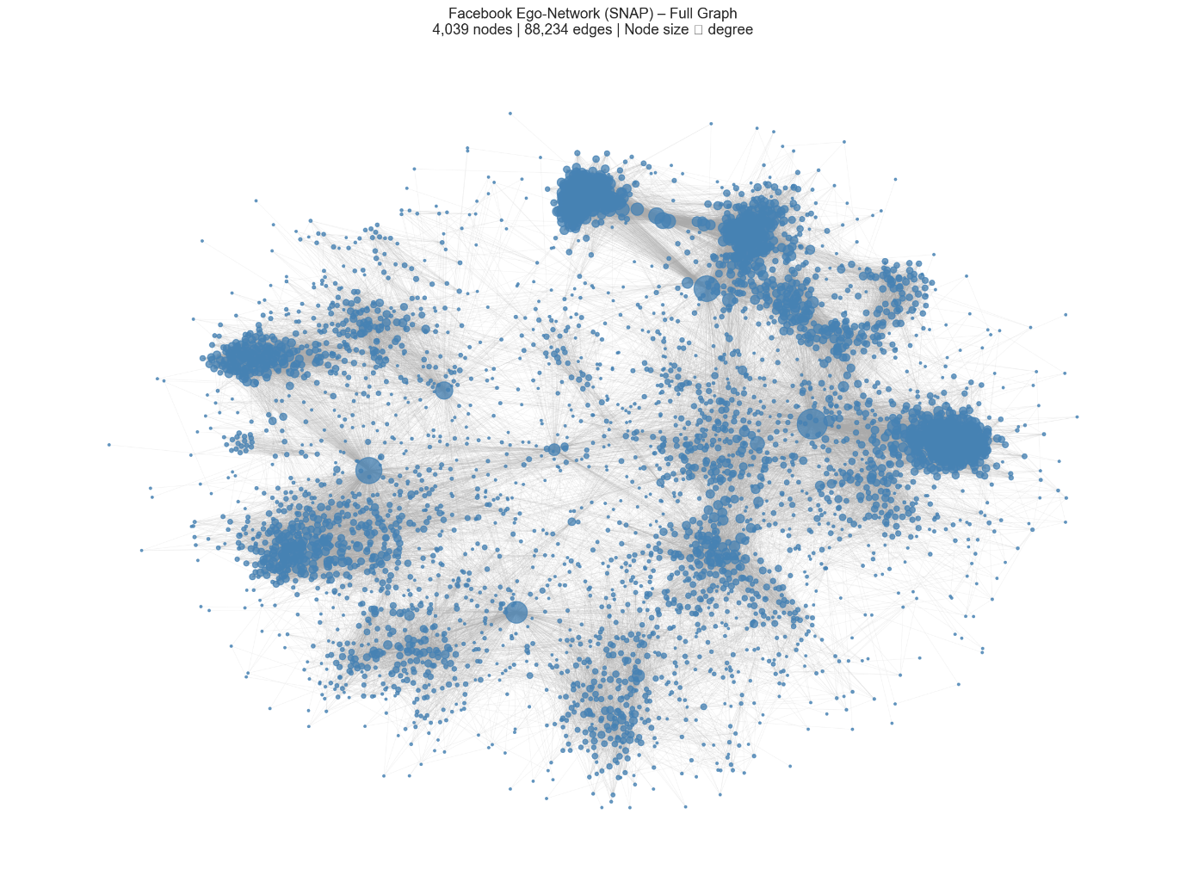
Figure 1. Full graph with node size proportional to degree (spring layout).

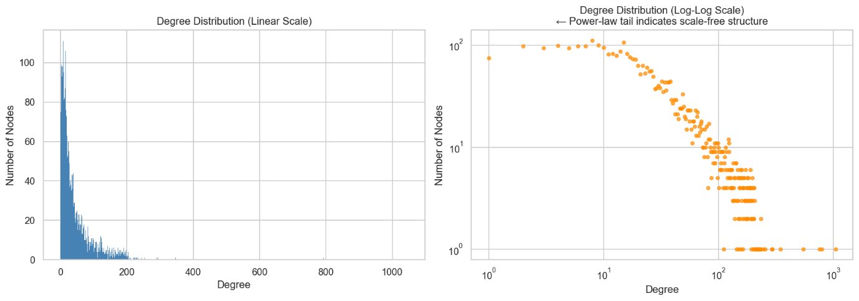
Figure 2. Degree distribution on linear scale (left) and log-log scale (right). The approximately linear log-log tail confirms scale-free power-law behaviour.

  - Edge Betweenness Centrality
Edge betweenness centrality (EBC) quantifies the fraction of all shortest paths traversing a given edge (Girvan & Newman, 2002). EBC was computed using the k=500 source-node sampling approximation (Brandes, 2001). Summary statistics: minimum=0.000000; maximum=0.021795 (edge 107–1684); mean=0.000005; SD=0.000137. The distribution is heavily right-skewed (Figure 3): the vast majority of edges carry near-zero EBC while a small number of bridge edges carry two orders of magnitude more traffic. All top-10 highest-EBC edges involve hub nodes 107 and/or 1684, which confirms their role as primary inter-community connectors whose removal would most rapidly fragment the network, the core principle of the Girvan-Newman algorithm.
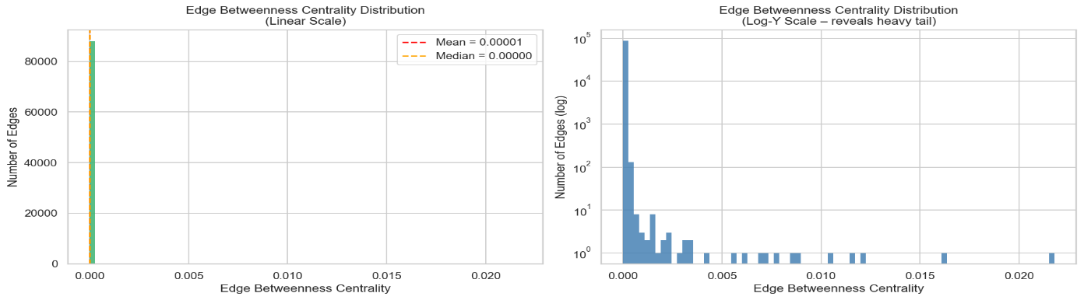
Figure 3. EBC histogram on linear scale (left) and log-Y scale (right), revealing the heavy right tail.
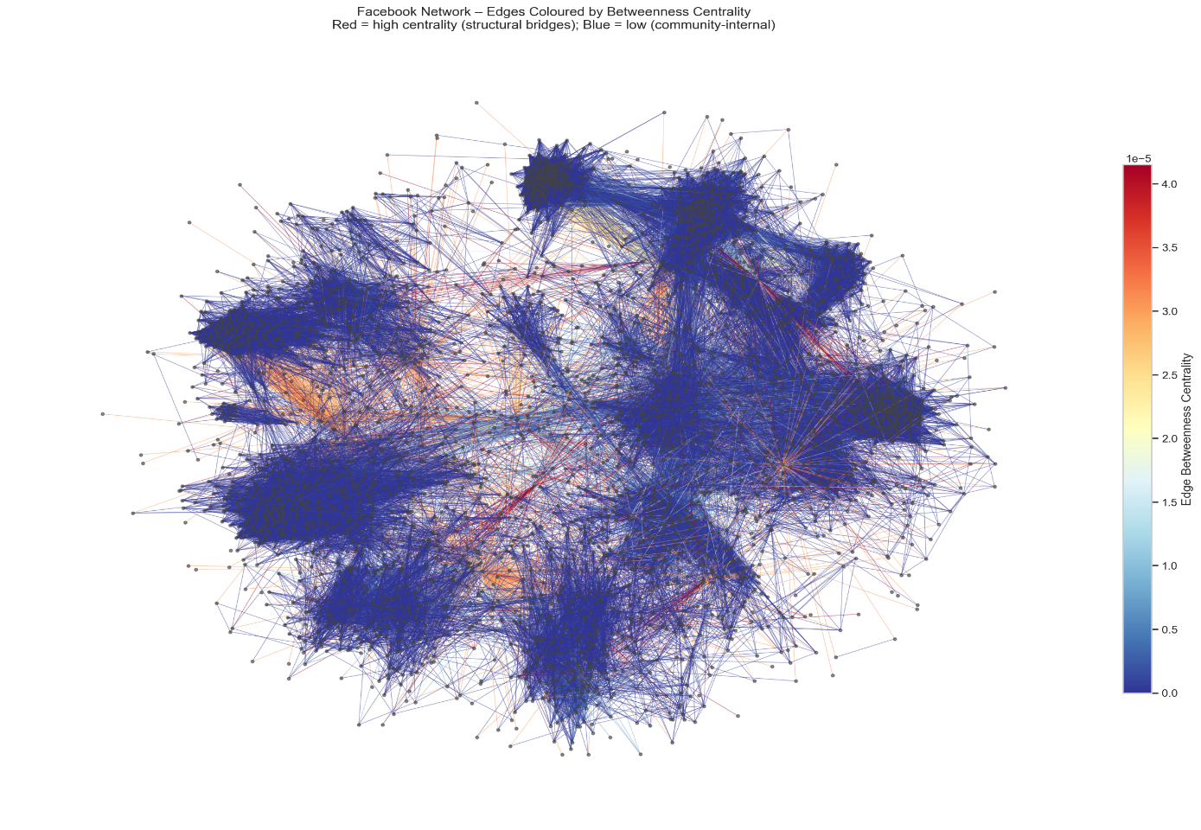
Figure 4. Full network with edges coloured by EBC (red=high betweenness/bridge; blue=low/community-internal).

  - Community Detection
Label Propagation Algorithm (LPA) on Full Graph
The Label Propagation Algorithm (Raghavan et al., 2007) was applied to the full 4,039-node graph. The Label Propagation Algorithm (Raghavan et al., 2007) was applied to the full 4,039-node graph. LPA initialises each node with a unique label and iteratively assigns each node the majority label of its neighbours until convergence, with O(m) time complexity per iteration and no prior specification of community count required. On the full graph, LPA detected 44 communities with modularity Q=0.7368 (Figure 5); the five largest communities contained 3,024 nodes (74.9%). This modularity value, well above the conventional Q=0.3 threshold (Newman, 2010), is a confirmation of strongly pronounced community organisation, consistent with the ego-network construction where each underlying ego-network naturally forms a densely interconnected subgroup.

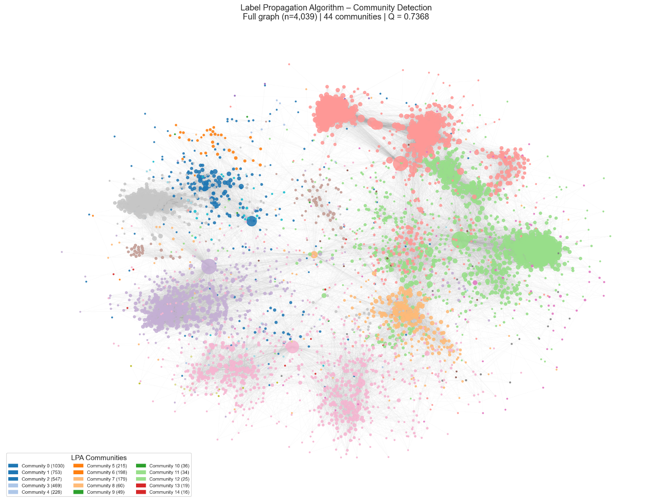
Figure 5. Full network coloured by LPA community assignment (44 communities).

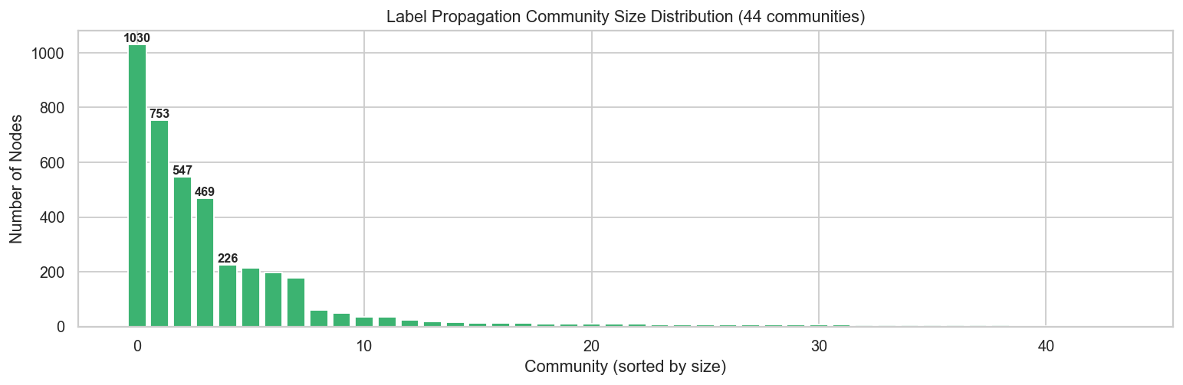
Figure 6. LPA community size distribution bar chart
Louvain Algorithm on Full Graph
The Louvain algorithm (Blondel et al., 2008) maximises modularity Q by applying a two-step iterative process: initially allocate each node to the community which maximises local modularity gain, then aggregate communities into super-nodes and repeat. With O(n log n) complexity and near-deterministic results, it is well-suited to the full graph scale. When applied to the same 4,039-node graph, Louvain identified 15 communities with modularity Q=0.8349 (Figure X), much higher than the modularity Q of LPA of 0.7368 across 44 communities. The 15 communities are larger and more balanced (mean 269 nodes; smallest 19), suggesting Louvain resolves the network's ego-network structure more cleanly, merging the many small peripheral fragments that LPA assigns as separate groups into coherent larger communities.
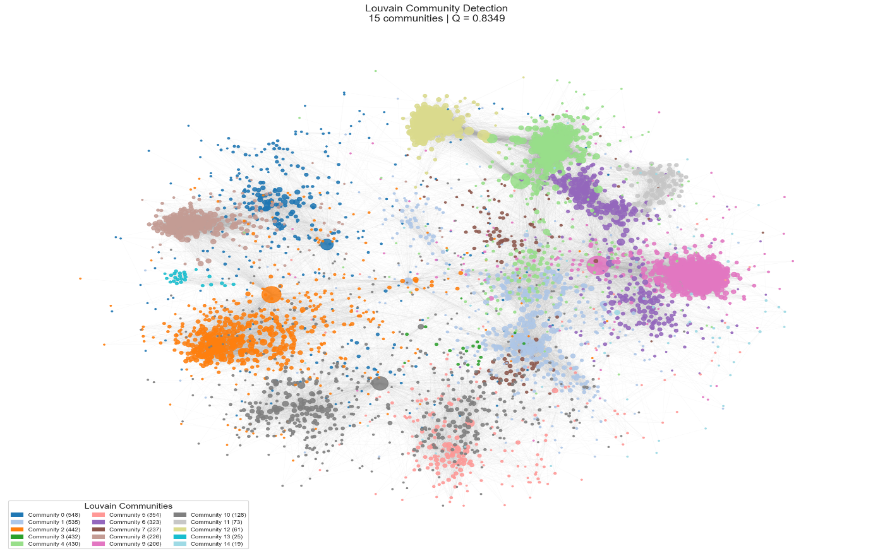
Figure 7. Full network coloured by Louvain Community assignment (15 communities).
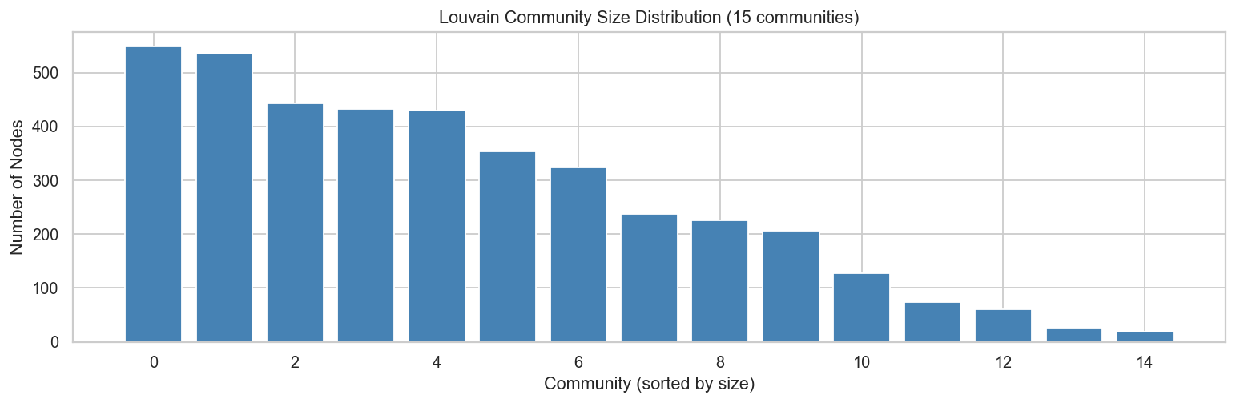
Figure 8. Louvain community size distribution bar chart
Comparison: LPA vs. Louvain on Full Graph
Table 2 compares LPA to Louvain on the same full graph to factor out variations in the input data. Neither algorithm requires any prior specification of community count, but they differ fundamentally in their approach. This distinction is shown in the results provided.
Metric | LPA | Louvain
Graph scope | Full graph | Full graph
Nodes / Edges | 4039 / 88234 | 4039 / 88234
Communities detected | 44 | 15
Modularity (Q) | 0.7368 | 0.8349
Largest community | 1030 nodes | 548 nodes
Smallest community | 2 nodes | 19 nodes
Mean community size | 91.8 nodes | 269.3 nodes
Time complexity | O(m) per iteration | O(n log n)
Deterministic? | No | Mostly deterministic
Approach | Majority-label propagation | Modularity optimisation
Table 2. Head-to-head comparison of LPA and Girvan-Newman on the identical subgraph (Full graph).

Fair Comparison: LPA vs. Girvan-Newman on Shared Subgraph
A direct comparison of LPA (run on the full 4,039-node graph) with Girvan-Newman (which is computationally expensive at O(m²n) for the full graph) would be methodologically unfair, as any observed difference could reflect the different input graphs rather than genuine algorithmic behaviour. Both algorithms were therefore applied to the identical subgraph G_gn: the largest connected component of the top-150 degree nodes (n=148, m=5,614). This dense hub-node is the region of the network most likely to exhibit testable community structure. Results are compared in Table 3.

Metric | LPA | Girvan-Newman
Graph scope | Top-150 degree subgraph | Top-150 degree subgraph
Nodes / Edges | 148 / 5,614 | 148 / 5,614
Communities detected | 2 | 9
Modularity (Q) | 0.1844 | 0.1868
Largest community | 109 nodes | 102 nodes
Smallest community | 39 nodes | 1 node
Mean community size | 74 nodes | 16.4 nodes
Time complexity | O(m) per iteration | O(m²n)
Deterministic? | No (stochastic) | Yes
Approach | Majority-label propagation | Iterative EBC-edge removal
Table 3. Head-to-head comparison of LPA and Girvan-Newman on the identical subgraph (n=148, m=5,614).

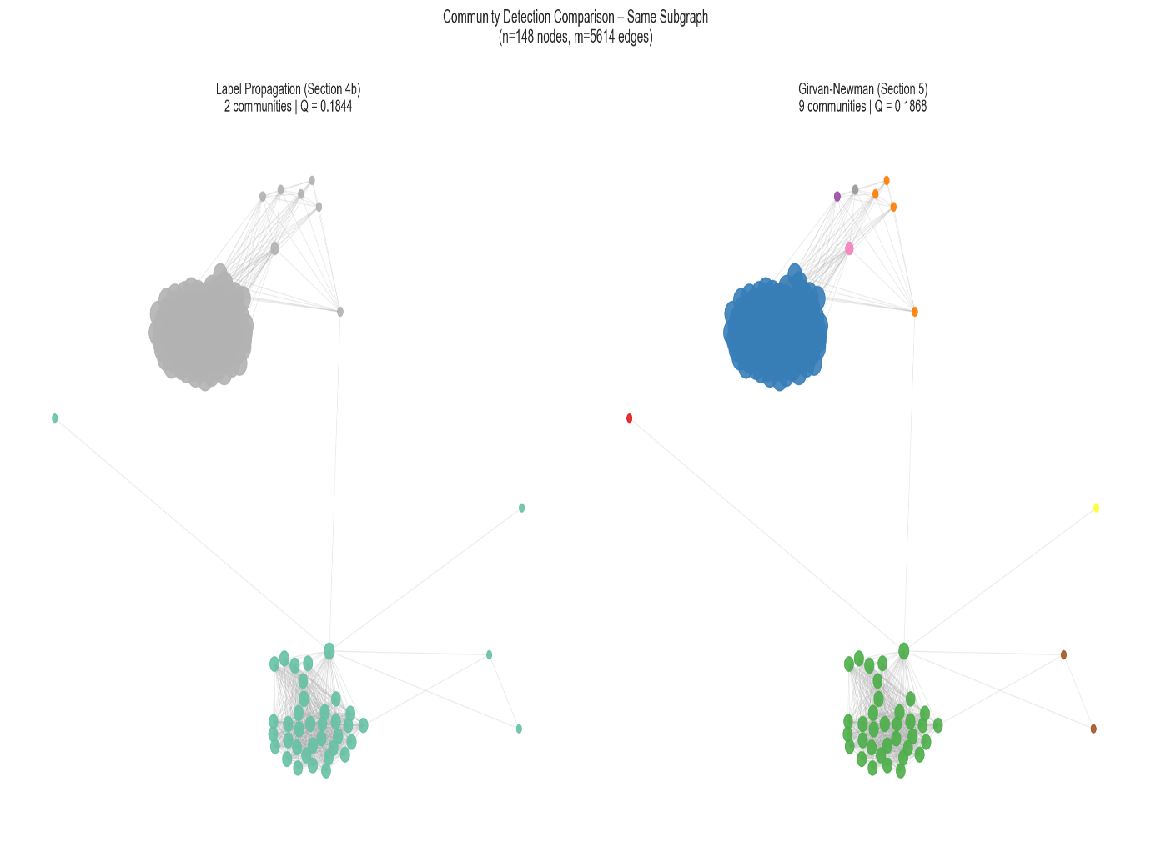
Figure 9. Both algorithms on G_gn with identical node positions (spring layout).

- Discussion
Full-graph analysis of Facebook SNAP network confirms the network as a scale-free, small-world social network: power-law degree distribution, high local clustering (0.606), and short global path length (3.58 hops). A comparison of LPA and Louvain on the full graph reveals a significant methodological difference. The stochastic label propagation of LPA produced 44 communities (Q=0.737), many of which are small peripheral groups, which reflects the sensitivity of the algorithm to tie-breaking in loosely connected regions. Louvain's modularity optimisation produced 15 larger, more coherent communities (Q=0.835), better reflecting the underlying ego-network structure of the dataset. Each of the 10 original ego-networks likely maps to one or two Louvain communities, with remaining communities capturing inter-ego bridge clusters. Louvain is the preferred algorithm for this network, because it has higher modularity and a more interpretable partition. The fair subgraph comparison between LPA and Girvan-Newman confirms that the dense hub-node core is inherently weakly modular (~Q=0.185 on both), as hub nodes by definition connect many communities and cannot be neatly partitioned. Girvan-Newman's 9 communities over-fragment the subgraph into singletons, while LPA produces a coarser but more stable two-partition. Neither is superior for this subgraph; the result underscores that algorithm choice matters most when working at full-network scale. Louvain's modularity optimisation delivers the most meaningful partition.
- Conclusion
The Facebook SNAP ego-network is a scale-free, small-world graph with strong community organisation (LPA Q=0.737; 44 communities on the full graph). Edge betweenness centrality identified a small number of critical bridge edges, most notably the 107-1684 link (EBC=0.022), as the inter- community connectors whose disruption would most rapidly fragment the network. Louvain community detection on the full graph yields the most interpretable result, 15 communities (Q=0.835) broadly corresponding to the underlying ego-networks, and outperforming LPA's 44-community partition (Q=0.737) in both modularity and coherence. The hub-node subgraph comparison confirms that the dense hub core produces a weakly modular bridge region by structural design, as both Girvan-Newman and LPA converge to similar modularity (~0.185).
These findings demonstrate that the network is simultaneously locally cohesive and globally accessible: a structural duality that enables both strong social group identity and rapid network-wide information diffusion.

References
Barabási, A.-L. and Albert, R. (1999) ‘Emergence of scaling in random networks’, Science, 286(5439), pp. 509–512.
Brandes, U. (2001) ‘A faster algorithm for betweenness centrality’, Journal of Mathematical Sociology, 25(2), pp. 163–177.
Girvan, M. and Newman, M.E.J. (2002) ‘Community structure in social and biological networks’, Proceedings of the National Academy of Sciences, 99(12), pp. 7821–7826.
Hagberg, A., Swart, P.J and Schult, D.A (2007) Exploring Network Structure, Dynamics, and Function Using NetworkX. Los Alamos: Los Alamos National Laboratory.
Leskovec, J. and Mcauley, J. (2012) ‘Learning to discover social circles in ego networks’, Advances in Neural Information Processing Systems, 25, pp. 539–547.
Newman, M.E.J. (2010) Networks: An Introduction. Oxford: Oxford University Press.
Raghavan, U.N., Albert, R. and Kumara, S. (2007) ‘Near linear time algorithm to detect community structures in large-scale networks’, Physical Review E, 76(3), 036106.
Watts, D.J. and Strogatz, S.H. (1998) ‘Collective dynamics of small-world networks’, Nature, 393(6684), pp. 440–442.

